Board of Directors Meeting Notice
The Board of Ashfield, Buckland & Shelburne Councils on Aging and The Senior Center in Shelburne Falls will hold their regular monthly meeting on:
Thursday Dec 9, @ 3:00 pm
Location: Senior Center 7 Main Street, Shelburne Falls.

Topics to be Discussed (including but not limited to):
- Call to Order
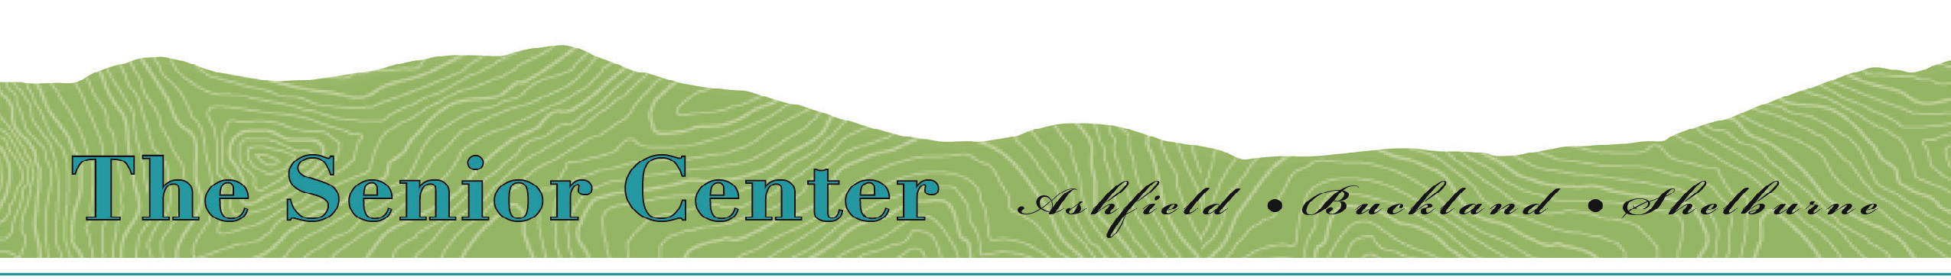
- Secretary’s Report
- Treasurer’s Report
- Director’s Report
- Committee Reports
- COA’s Report
- Senior Center Foundation Report
- Old Business
- New Business – Review of FY23 SC Budget
- Other business not reasonably foreseen 48 hours prior to meeting
- Adjournment / Next Meeting January 13,2022

